[Document subtitle]

**<Saving Electricity>**

 **Project name*:***Saving electricity

 **Project sponsor:** Ministry of electricity and energy.

 **Project manager:** Kerolos Nagy Azmy

 **Purpose of the project:** helping citizens to conserves electricity.

 **Business case:**

the application in used to bring money by saving electricity and control electricity-power and function through Egypt. If you keep devices plugged in and running when they're not in use the result is an increase in electrical use and, consequently, a bump in the amount of greenhouse gases that enter the atmosphere. Leaving your laptop plugged in all the time will use nearly 300 kilowatt hours (kWh) of electricity each year and a desktop computer left to idle will use more than 600 kW of electricity annually.

Even leaving your fully charged cellphone attached to its charger can waste almost 20 kWh a year it led to raise the cost of electricity bill and affect in your salary.

Conserving energy is not just about saving on your electricity costs.

The Organization for Economic Co-operation and Development warns that given the current trends, energy-related emissions will increase by 70 percent by 2050. This can accelerate the negative consequences of climate change including higher temperatures and a rise in the frequency of extreme weather events for this the ministry of electricity decided to make a mobile phone app that enable you to control of your home electricity from any place. The app will be attached with the all devices at your home and about it you can turn on/off any devices you want from any place even if you are out of home,

the app also will see you which devices are turned on and which turned off.

 **Project resources:**

1. A team of electrical engineering.
2. A team of programing.
3. Device of receiver

**Budget:** 500,000$.

**Staff:**

* A team of electrical engineers.
* A team of programmers.

Vendor:

Marketing companies, and internet markets (like Amazon, and Google play)

 **Budget:**

500,000 $ (includes servers, project licenses, developers, designers, training)

**Constraints**:

1-The project must take a year

2-The project must not exceed 500,000 $.

3-laptops and computers must be bought from dell company.

 **Assumptions:**

1- The project does not take more than 1 year 2- The cost no more 500,000$.

3- Efficiency in the devices.

 **High level risks:**

1. Damage in the receivers.
2. Increase in the cost.
3. The lack of efficiency sufficient in the receiver or the teams.
4. Not to satisfy the users of product.

# **Team Members:**

* Maged Ibrahim Shehata
* Kerolos Ibrahim Nageh
* Kerolos George Refaat
* Kerolos Nagy Azem
* Maged Ibrahim Altanany
* Fatma Mahmoud Wadie Shreif
* Fatma Mahmoud Abdeltawab

\***Project scope:**

**1-Project scope description:**

1-It is an application you use to control the electric devices so that you can Turn on/off any device at home from anywhere.

2-The app also will show you all devices at home whatever they turn on/off.

3-You can pay the electricity bill with the app.

**2-Project acceptance criteria:**

1-Paying the electricity bill.

2-Beutifull user interface.

3-Easy to use, faster and comfortable.

**3-Project deliverables:**

1-Project plan, reports, documents and resources which return to the Company.

2-Saving money, electricity and time.

**4-Project execution:**

One of customers’ requirements that the app show him the average of using electricity every month, but the sponsor and managers Refuse this request as it need a lot of time and cost.

**5-project constraints:**

1**-**Rules of company and policies.

2-Budget.

3-Time and submit.

**6-Project assumptions:**

This application can run only on the **IOS** and **Android** operating system.

**\*WBS:**

1.4

Finishing

1.1

Starting

1.4

Finishing

1.3

Coding

1.2

Hardware and

Software

1.1.1

Requirements

1.1.2

Policies

1.1.3

Doing study

About the project

1.1.4

Interface the Application

Plan the Project

1.4.1

Test the Application

1.4.2

Explain and

Fixed Errors

1.4.3

Finish the Application

1.4.4

Install the Application

1.3.1

Dividing Taske

1.3.2

Coding the function in all Tasks

1.3.3

Test functions

1.3.4

Interface the Application

1.2.1

Procurements

1.2.2

Operating System

1.2.3

Testing Devices

1.4.1

Test the Application

1.4.2

Explan and Fixed Errors

1.4.3

Finish the Application

1.4.4

Install the Application

1.4.1

Test the Application

1.4.2

Explan and Fixed Errors

1.4.3

Finish the Application

1.4.4

Install the Application

j

j

*WBS dictionary:

**1.1**

Starting



1.1.1

Requirement

Meeting with team Stakeholder and Sponsor

Manager

& Team Members

115

December

2021

4

December 2021

2021



***Work Package ID***

***Work Package Name***

***Description***

***Person***

***Start Date***

***End Date***



1.1.2

Policies

Know the Policies and Recommends of the minister

Manager

5

2021

December

2021

11

December



***Work Package ID***

***Work Package Name***

***Description***

***Person***

***Start Date***

***End Date***

*Responsibility Matrix:

|  |  |  |  |  |  |  |  |  |
| --- | --- | --- | --- | --- | --- | --- | --- | --- |
|  | Computer Software System Development | Computer Hardware Development | Front-End  Development | | Back-End Development | Creat Database | Make secure Access | Test the Application |
| Create Application | A | S | R |  | |  | S |  |
| Test the Application | A |  | S | | S |  |  | R |
| Package the Application | S |  |  | | R |  |  | S |
| Test Application  Release | S | R |  | |  | S | S |  |
| Push the application to the workstations | A |  |  | | S | S | R | S |

|  |  |
| --- | --- |
| **A** | Approves |
| **R** | Responsible |
| **S** | Supports |

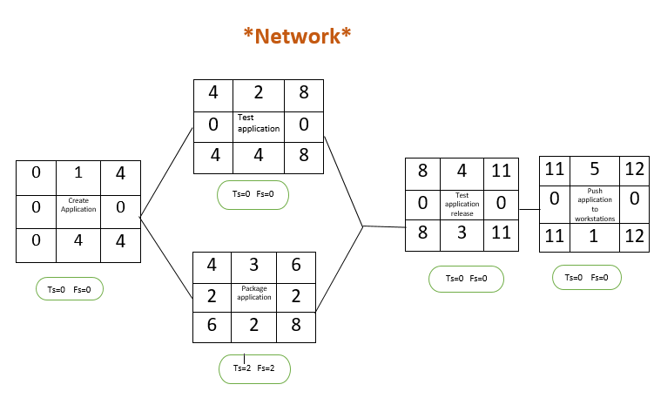

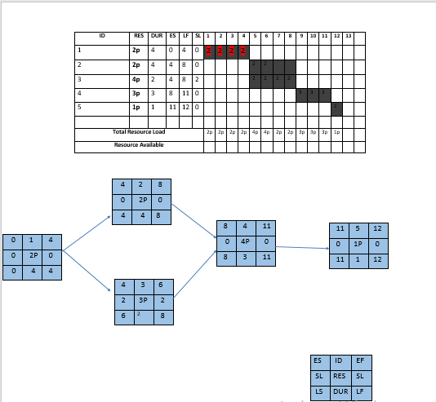

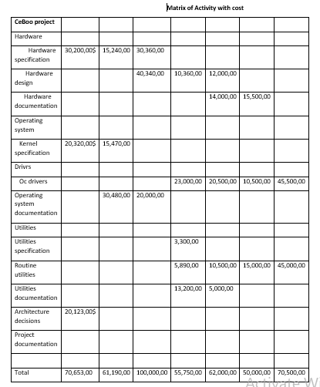

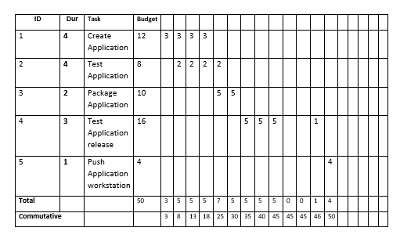**Baseline Budget**

**The risks which face our project:**

* The lack of efficiency sufficient in the receiver.
* Funders’ dissatisfaction with profits and results.
* Increase in the cost.
* Lightning and thunder damage which leads to a lot of damages in receiver.
* Damages in equipment and devices comes from both direct and indirect lightning strikes.

**How we deal with these risks:**

* Using equipment that withstands high pressure of electricity to withstand the impact of lightning and thunder.
* Using efficient receivers with insulators to withstand this great pressure.

**How we monitor our project:**

1. Projects meetings (weekly or daily).
2. Individual catchups with team.
3. Timely updates on tasks.
4. Weekly status reports.

5.Timely completion of timesheets